E-Commerce Platform

* (a) Creating the tables.



* (b) Inserting sample data.

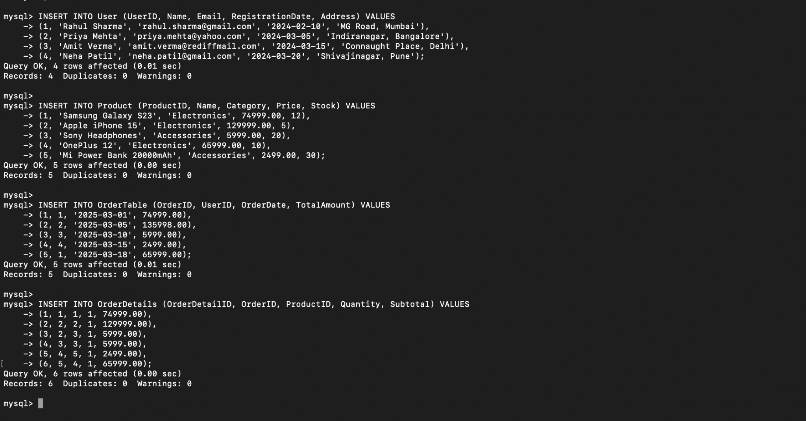

* (c) Retrieve total sales per product.

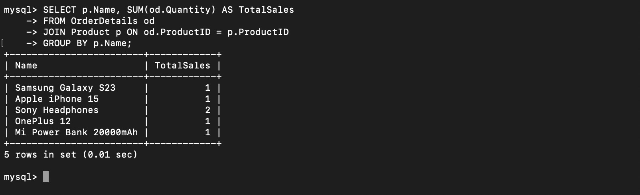

* (d) Find the most purchased product category.

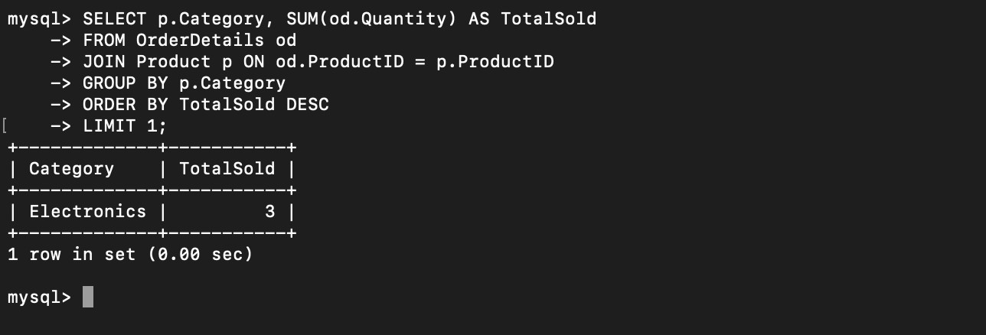

* (e) Display users who have placed more than 5 orders.

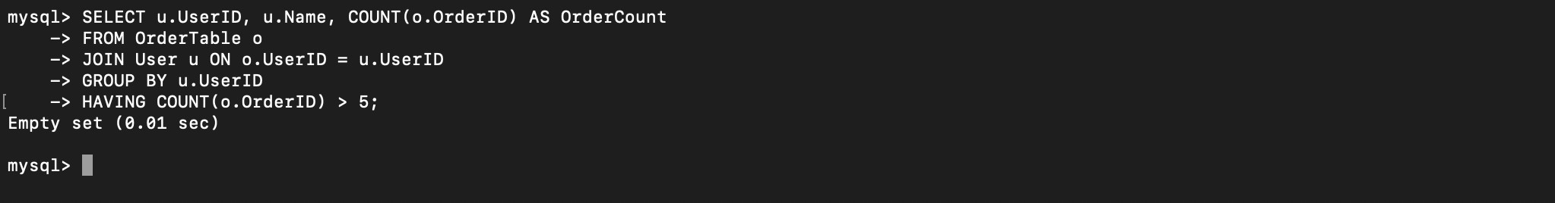

* (f) Retrieve products with less than 5 stock remaining.



* (g) Find orders placed in the last 30 days.

